**Pre-Registration Demographic Controller Performance Testing**

**Test Summary:**

|  |  |
| --- | --- |
| Kernel Request | Demographic Controller |
| Base URL | https://integ.mosip.io |
| Execution Window | 2019/01/09 01:45 PM IST to 2019/01/09 02:15 PM IST |
| Maximum User Load | 200 |
| Tool Used | Jmeter |

**APIs transaction Summary:**

|  |  |  |  |  |  |  |  |
| --- | --- | --- | --- | --- | --- | --- | --- |
| Label | #Sample | Average | 90% line(ms) | Min(ms) | Max(ms) | Error% | Throughput/Sec |
| Create form data | 5238 | 51219 | 60234 | 472 | 81277 | 63.99% | 2.29 |
| Get Pre-Registration data | 5123 | 7024 | 16113 | 0 | 33540 | 4.29% | 2.30 |
| Get Pre-Registration data By Date And Time | 5120 | 3868 | 10136 | 54 | 42599 | 0.00% | 2.30 |
| Update Pre-Registration status | 5083 | 2341 | 8094 | 0 | 56031 | 4.33% | 2.30 |
| Fetch the status of an application | 5067 | 2617 | 8426 | 0 | 41541 | 4.34% | 2.29 |

Test Observations:

Create form data API’s response time is higher than the normal range and returns bad gateway error over the period of time. Error % for form creation is 63.99%.

Response Times Over Time

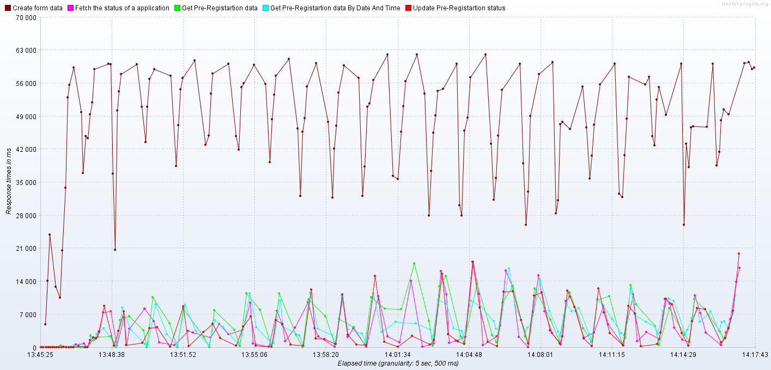

Transactions per Second

